**HTML loop Attribute**

Last Updated : 29 Aug, 2024

The **HTML loop Attribute**is used to *restart the audio and video again and again after finishing it*. It contains the Boolean value.

**Syntax:**

<element loop>

**Applicable**

* <audio>
* <video>
* <marquee>
* <bgsound>

**Example 1:** Below Example illustrates the use of loop attribute in **<audio>** element.



1

<!DOCTYPE html>

2

<html>

3

​

4

<head>

5

<title>

6

Audio loop Attribute

7

</title>

8

</head>

9

​

10

<body style="text-align: center">

11

​

12

<h1 style="color: green">

13

GeeksforGeeks

14

</h1>

15

<h2 style="font-family: Impact">

16

HTML Audio loop Attribute

17

</h2>

18

<br>

19

​

20

<audio id="Test_Audio"

21

controls loop>

22

<source src="beep.mp3"

23

type="audio/mpeg">

24

</audio>

25

</body>

26

​

27

</html>

**Output:**

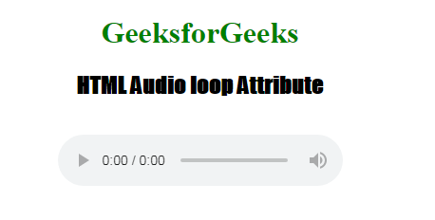

**Example 2:** Below Example illustrates the use of loop attribute in **<video>** element.



1

<!DOCTYPE html>

2

<html>

3

​

4

<head>

5

<title>

6

HTML video loop Attribute

7

</title>

8

</head>

9

​

10

<body>

11

<center>

12

<h1 style="color:green;">

13

GeeksforGeeks

14

</h1>

15

​

16

<h3>HTML video loop Attribute</h3>

17

​

18

<video width="400"

19

height="200"

20

controls loop>

21

22

<source src="Canvas.move_.mp4"

23

type="video/mp4">

24

<source src="Canvas.move_.ogg"

25

type="video/ogg">

26

</video>

27

</center>

28

</body>

29

​

30

</html>

**Output:**

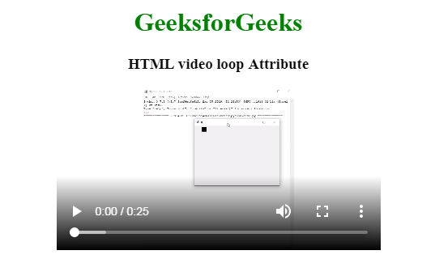

**Supported Browsers:** The browsers supported by **loop Attribute** are listed below:

* [Google Chrome](https://www.geeksforgeeks.org/google-chrome-browser)
* [Edge](https://www.geeksforgeeks.org/microsoft-edge-browser)
* [Firefox](https://www.geeksforgeeks.org/mozilla-firefox-browser)
* [Opera](https://www.geeksforgeeks.org/opera-browser)
* [Safari](https://www.geeksforgeeks.org/apple-safari-browser)